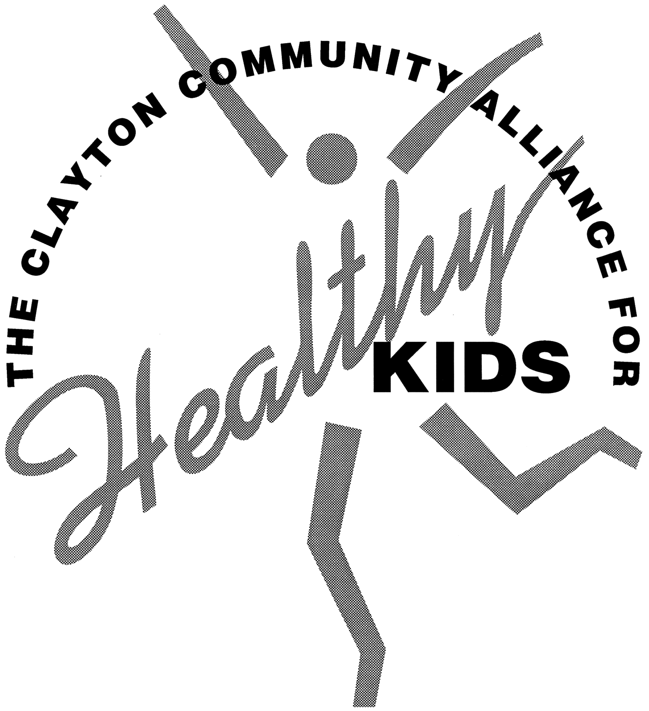
Dec. 10, 2009
Minutes

Present: Katie Monteil, Amy Gage, Lisa Avery, Lily Raymond, Rob Wood, Korey Golcynski, Val Colombo, Christina Perrino, and Anne Wilding

II. We would like to extend a warm welcome to Rob Wood, the new School Resource Officer at WMS!

III. Nov. 5 minutes were approved as written.

IV. Written report for Board of Education

Anne presented information about the Alliance at the Nov. 10 Principal’s meeting. The elementary principals seemed particularly excited about our work and unaware of some of what we do.

On-line parent survey – Christina Perrino. The survey had a few revisions which is why it didn’t go out as planned. We cut some additional questions to get to what the BOE wants to know and keep it short. It will go out on E-News on Dec. 11 and go out again in January.
- Lisa will put together the numbers of students who participate in the each WMS Social Activity.
- Anne will request letters of support for the Alliance. If you would like to submit one to the BOE, please e-mail or mail it to Anne at Clayton High School.
- Anne will put together a survey for administrators, counselors, and parent educators seeking feedback regarding what they are looking for from the Alliance. Do they find what we do helpful? What other things would they like for the Alliance to do? What do they feel their role should be?
- Anne will contact the PTO Council about having a representative from each school. She will also work on a job description for the position.

VI. Funding

2009-2010 Missouri Prevention Assistance Mini-Grant
- Our application for $4,909.18 to offer one SCT and one GGC class in the Spring of 2010 was accepted for Curriculum - $2,293.58, Facilitators $2,300.00, Countertop document holders to display materials $315.60.
- The spring classes have been scheduled and will appear in the Family Center catalog.
  - Guiding Good Choices for parents of 4th-7th graders
Tuesday nights, Mar. 30, April 6, 13, 20, 27, 2010. The April 20 Class includes 4th-7th graders At the Family Center, 6:15-8pm. The cost is $25 & includes all 5 classes and your book. Childcare is available for an additional $25 for all 5 classes.
  - Staying Connected with Your Teen for parents of 7th-12th graders
Meets twice from 6:15 – 8:00 p.m. in the Administrative Center on Feb. ?? (we need to change the date because of the parent forum) to discuss Chapters 1-4 and Mar. 2 to discuss Chapters 5-7. The cost is $25 for the classes and book. There is a $40 deposit for the DVD that is returned.

C. Funds from WMS Social Activities - $7,826.62
- Wait for parent survey results and feedback from the BOE after our report.
- Peers Protecting Peers may submit applications to us for use of some of the funds.
- Katie ordered books and DVDs for the WMS parent library with the $500 we donated.
- We will pay Tina Meier and Marian McCord to do a Parent Forum on Feb. 16 at WMS. See below.

VI. Neighborhood Coffees. The materials are ready to go.
Please consider hosting or co-hosting a coffee and calling people personally asking them to host one. Lisa volunteered to make personal requests to people she knows at each school. Thank you!!

VII. Parent Forums

A. Internet Safety February 11 at 7:00 in the CHS Auditorium for WMS/CHS Parents
Presenters: CHS SRO John Zlatic, and Detective Kenny Nix, Founder of the St. Louis Regional Computer Crime Enforcement Group and member of the U.S. Attorney General’s Computer Crimes Task Force.
Handouts – Val Colombo and Anne Wilding

- Bullying and Adolescent Mental Health – Tuesday, Feb. 16 from 7:00 – 8:30 p.m. at the WMS Auditorium
Presenters: Tina Meier from the Megan Meier Foundation and Marian McCord from CHADS Coalition.

C. Community Alliance 5th Grade Family Night
- Clayton Parks and Rec will organize community building activities for the 5th graders
- For Parents:
  - Overview of the Community Alliance featuring the WMS Social Activities, Guiding Good Choices, and Neighborhood Coffees
  - Parks and Rec. share middle school programming
  - Family Center- share child development information. Anne will work with Katie on a format. We discussed finding ways for parents to be able to talk to each other and ask questions of current WMS parents.
- Lisa and Amy will work together to have Girl Scouts provide childcare as a service project.

VIII. Parents Page
A. Issue #36 on marijuana was approved.
B. Question for Issue #37 – Springbreak.

IX. WMS Social Activities – Lisa Avery
A. Add sending a welcome E-mail in the fall outlining what the Community Alliance does, how the
WMS Social Activities program works, and expectations for parents and students.
B. Winter Activities
- 6th Grade – Broomball on Jan. 21 from 3:30 –5:45 at Shaw Park
- 7th Grade – Ice Skating on Jan. 15 from 7:00 – 9:30 p.m. at Shaw Park
- 8th Grade - Taste of St. Louis and Ice Skating on Jan. 10 from 5:30-7:15 at Shaw Park.
C. Registrations
1. 6th Grade 128 students have registered so far
2. 7th Grade 101 students
- 8th grade 79 students
D. Winter Service Project- Textile Recycling with Remains Inc. There will be a bin placed at WMS for:
Clothing, linens (e.g., bedding, towels, curtains, drapes), paired shoes, purses, belts. http://stlouis.missouri.org/citygov/recycle/Textiles.html

X. Peers Protecting Peers
A. Focus on underage drinking and seat belt safety in the fall.
Battle of the Belt

1.Initial seat belt check Oct. 12 : 86% of CHS students wore their seat belts; 13% did not.
Campaign – announcements, posters, extra seat belt check, seat belt convincer on Nov. 4.

2. Final seat belt check Nov 20: 96% of students wore their seat belt; 4% did not.
B. Human trafficking in the winter. They are working on an awareness campaign with a fundraiser to
give to a nonprofit with this focus.
C. Focus on adolescent depression and suicide in the spring.

UPCOMING OPPORTUNITIES
- Community Alliance Meetings: Jan. 14, Feb. 11, Mar. 11, Apr. 8, and May 27 from Noon-1:15. All meetings will be held in the Administrative Center, #2 Mark Twain Circle, Clayton, MO
- Parent Forum on Internet Safety: February 11 at 7:00 in the CHS Auditorium for WMS/CHS Parents
Presenters: CHS SRO John Zlatic, and Detective Kenny Nix, Founder of the St. Louis Regional Computer Crime Enforcement Group and member of the U.S. Attorney General’s Computer Crimes Task Force.
- Parent Forum on Bullying and Adolescent Mental Health – Tuesday, Feb. 16 from 7:00 – 8:30 p.m. at the WMS Auditorium Presenters: Tina Meier from the Megan Meier Foundation and Marian McCord from CHADS Coalition.

Thank you for supporting our students and families through the
Clayton Community Alliance for Healthy Kids!!

